**Create an IAM Group**

* **Creating an IAM group**
* In the IAM panel, click on Groups, and you will land on the Create New Group page

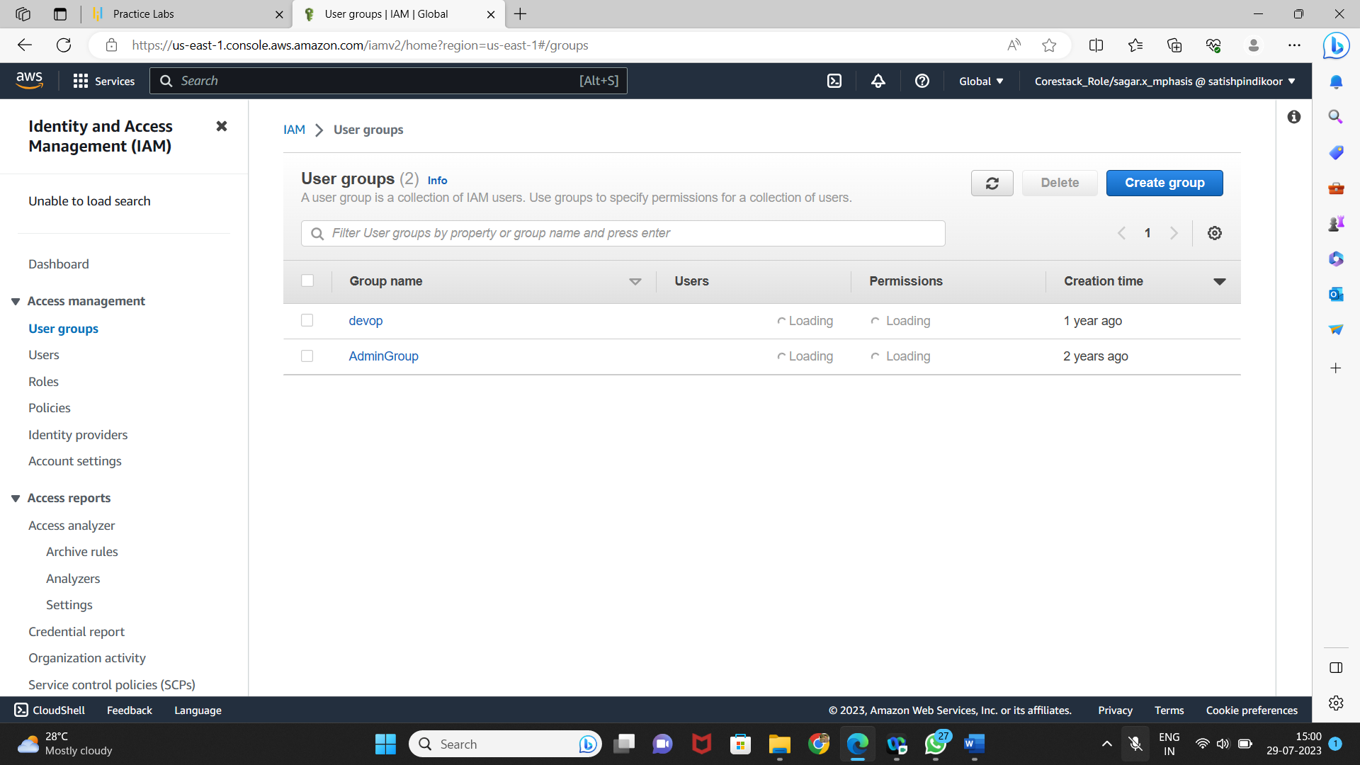

* Enter the group name

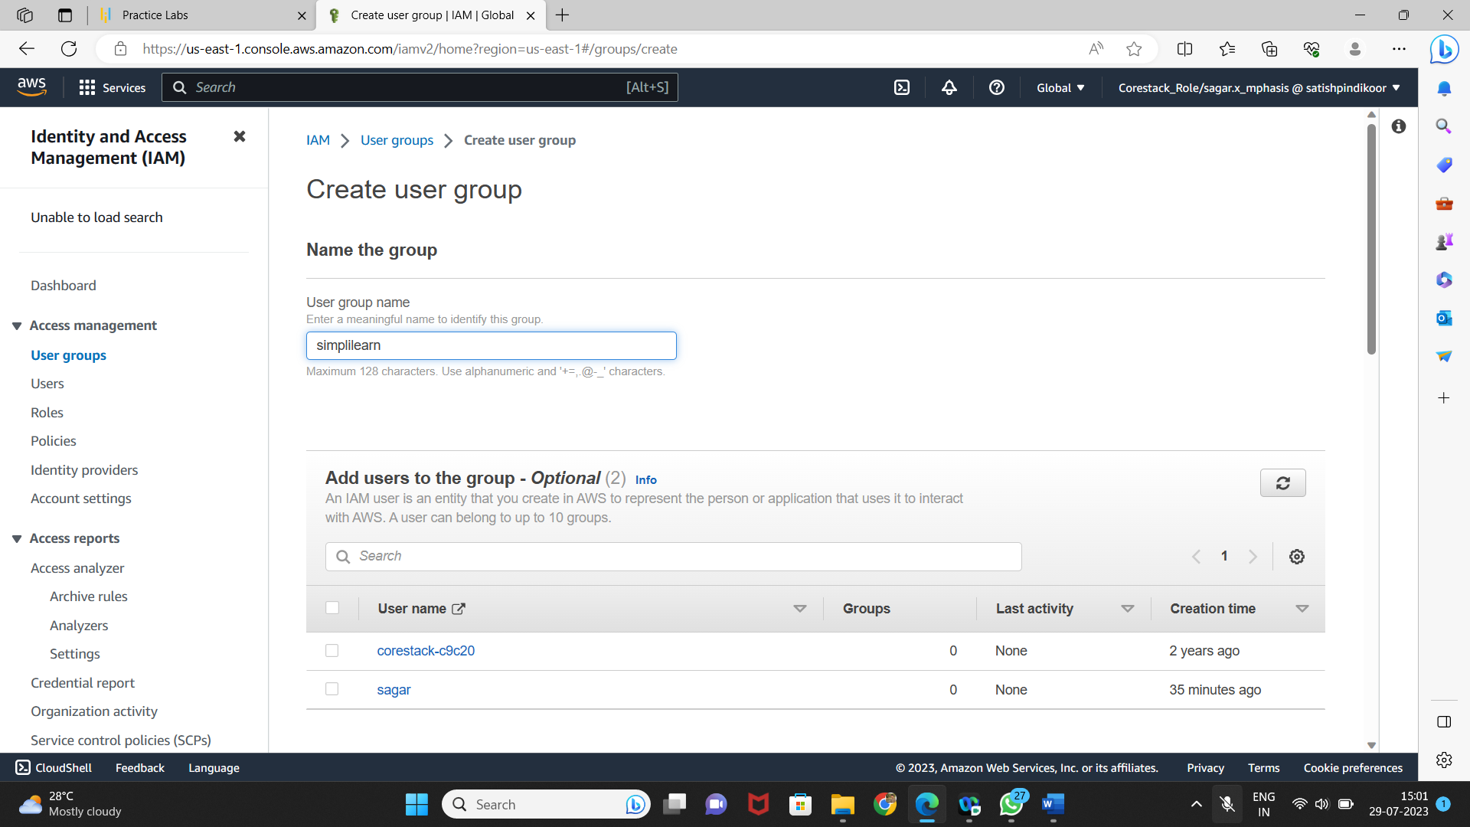

* **Assigning the required policy to the group**
* Assign the policy provided by AWS

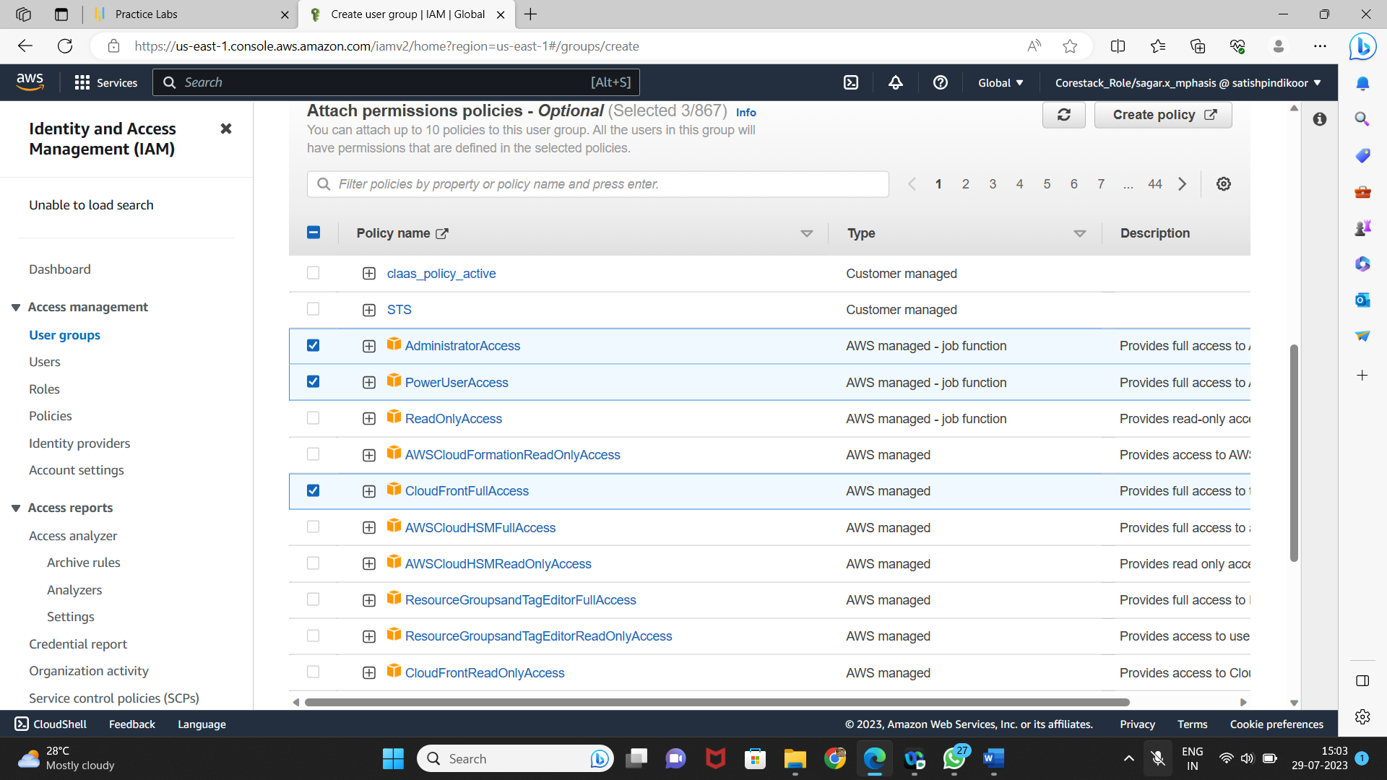

* Once the group is created, you can see the new group in the console

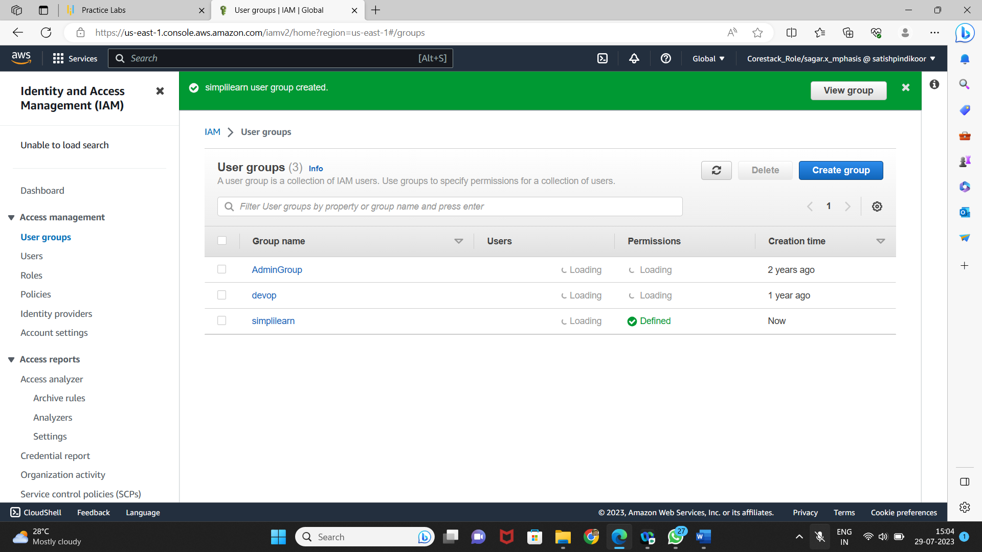

* You can add a user or a policy to the group any time

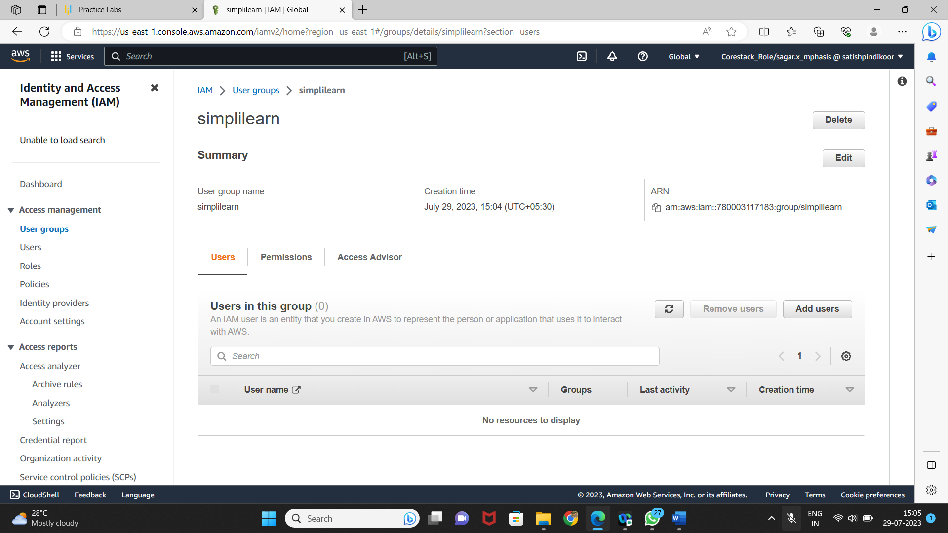

* You can see the user list by clicking on Add User

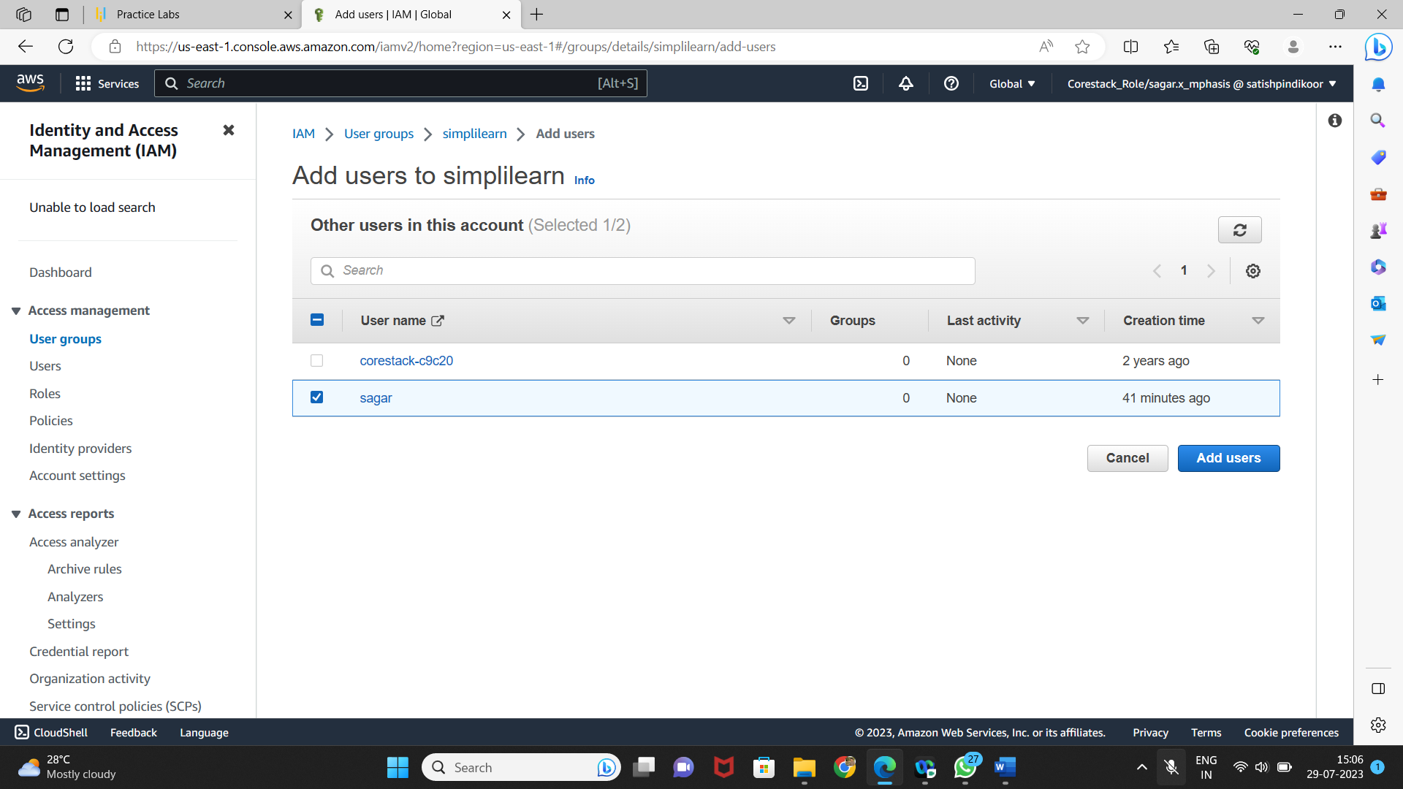

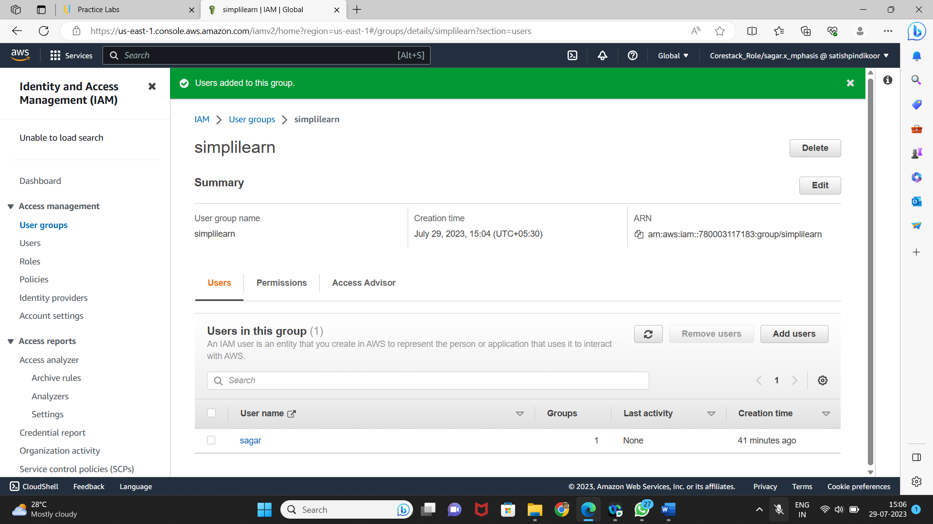

* You can also find all the policies added to the group

